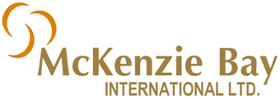
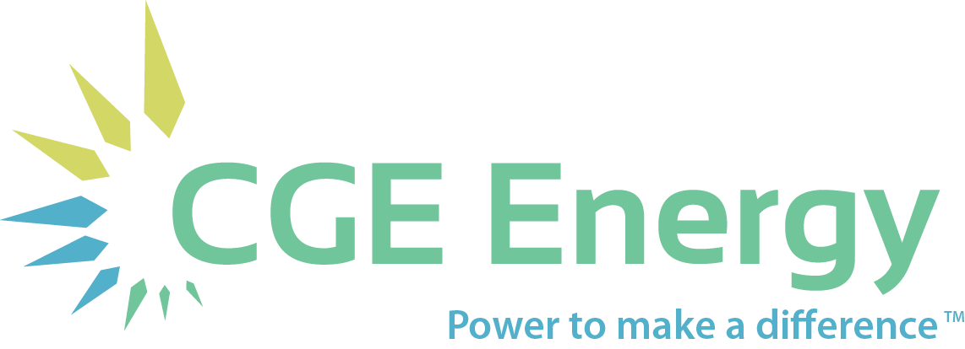

News Release

Release Date: December 16, 2014

McKenzie Bay Intl and CGE Energy Sign Definitive Merger Agreement

BRIGHTON, MI – McKenzie Bay International Ltd (MKBY:OTC) and Clean Green Energy LLC (doing business as CGE Energy, hereinafter “CGE”) today announced that the companies have signed a definitive agreement to merge. This finalized deal follows the companies’ Letter of Intent signed in October.
“I am very pleased with the final deal we have structured. I have always viewed this merger as in the best interests of the shareholders of both CGE and MKBY,” said Kevin Cook, current MKBY President, “As we begin the next chapter, the combined entity will have a much stronger market presence than either company could achieve on its own.”
“We are thrilled to have this public platform to change the world. It’s time for everyone to see our vision for a sustainable future.” said Bryan Zaplitny, current CGE President, “We will be good stewards with what has been entrusted to us.”
The companies said they expect their merger will be completed in two phases within the next 90 days. By January 31 the companies will functionally merge, with CGE being acquired by MKBY. A new leadership board will be enacted, with Bryan Zaplitny assuming the role of President/CEO.
The second phase will be completed by February 28, with the 1-for-25 reverse stock split and name change happening at this time. Additionally, the authorized limit of MKBY shares will be reduced from the current 300 million to 90 million shares.
Further information on the merger phases and details can be found at: www.mckenziebay.com.
Contact: Paul Schneider 248-446-1344, pschneider@cgeenergy.com.
About McKenzie Bay International:
McKenzie Bay is an energy technology holding company focused on the acquisition of exclusive rights to renewable energy technologies and is looking to acquire. www.mckenziebay.com
About CGE Energy
CGE Energy (formerly known as Clean Green Energy LLC) is an energy solutions provider headquartered in Brighton, Michigan. For more than 20 years, the company has provided energy optimization services and is now offering Power Purchase Agreements. Today the company serves customers in the U.S. and abroad, using energy efficient technologies that include Cree LED lighting and wind and solar generation. Visit our brand new website, http://www.cgeenergy.com
Certain statements made in this release constitute forward-looking statements and do not guarantee future performance. Actual results or developments may differ materially from the projections in the forward-looking statements.

